**Figure 2a: Forest plot of random effects pairwise meta-analysis for VTE recurrence.**

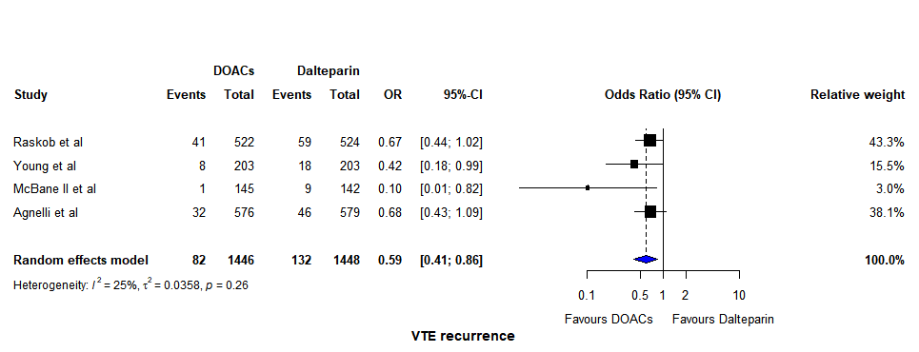

**Figure 2b: Forest plot of random effects pairwise meta-analysis for major bleeding.**

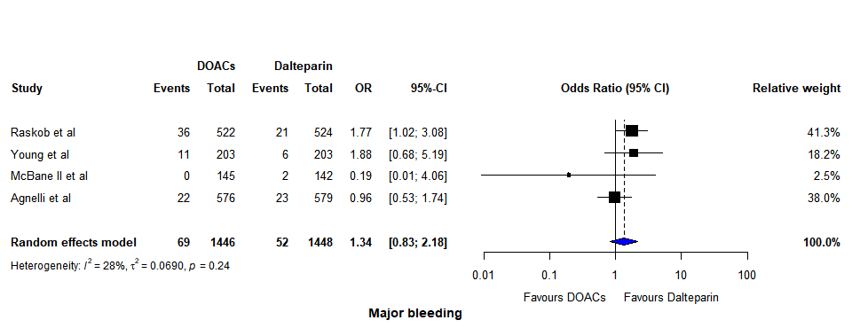

**Figure 2c: Forest plot of clinically relevant non-major bleeding**

